

Trauma informed training workshops in prisons

LVRN Evaluation Report

Dr Rebecca Fish

Lancaster University ARC

July 2024




Introduction

Prisoners are disproportionately affected by early trauma [1]. Efforts to reduce crime and prevent future offending can be strengthened through trauma-informed policies and interventions [2]. A key aim of the LVRN is to support Lancashire to be a ‘trauma-informed county’ and to embed trauma-informed practice within their partner organisations and workforce [3].
Trauma arises from one or more events that are experienced as harmful, having a lasting effect that can arise again when people are in real or perceived danger [4]. Such experiences alter the way an individual perceives their environment and relationships, leading them to expect danger, especially in situations that are similar in some way to the context of the original trauma [5].
Prisons in England and Wales began to implement trauma informed working in 2015 as part of growing recognition of trauma-related conditions and responses in community and mental health settings [6]. This was originally based on the work of American psychologist, Stephanie Covington, who defines trauma-informed services as:
‘…services that have been created to provide assistance for problems other than trauma, but in which all practitioners have a shared knowledge base and/or core understanding about trauma resulting from violence.’ [7: p22]
From these perspectives, trauma-informed approaches do not necessarily directly address trauma, but provide an environment in which trauma is not exacerbated. The key underlying principles that help to create and sustain such an environment include: trust; collaboration; choice; empowerment; and safety [8].
The LVRN has adopted the Substance Abuse and Mental Health Services Administration (SAMHSA) definition of trauma and their six principles of TI practice (see figure below taken from Lancaster University Applied Research Collaboration evaluation of LVRN trauma informed programmes [3]). The six principles form a framework for mental health organisations, that can be used in other settings such as prisons.
SAMHSA defines trauma informed practice as: recognising the widespread impact of trauma and understanding potential paths for recovery; noticing the signs and symptoms of trauma in clients, families, and staff; and responding by fully integrating knowledge about trauma into policies, procedures, and practices, to resist potential re-traumatization [9].
The aim of trauma informed practice training is to ensure practitioners are informed and skilled in recognizing the wide impact of trauma on the causes and effects of violent behaviour. This report evaluates prison-based trauma informed training workshops in Lancashire prisons.
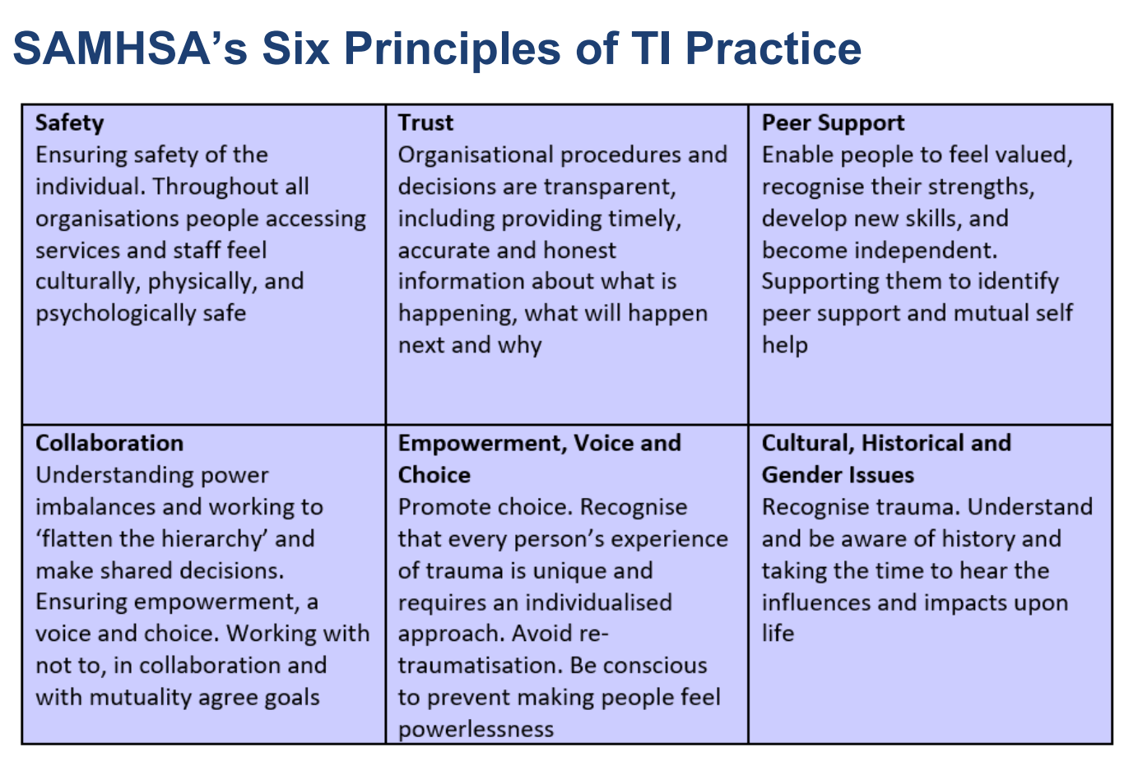

Trauma informed practice workshop feedback survey
The Trauma Informed Workshop Training took place over a full day, featuring lectures with slides interspersed with interactive sessions and videos. This feedback survey was completed by hand by delegates at the end of the workshop.
Respondents (n=66) consisted of 38 men and 25 women (with others not specifying their gender), working at Preston, Wymott, Garth, and Kirkham (see table 2 for details). Most respondents worked with men (only 2 responded that they worked with women and 6 worked with non-binary people) and 14 worked with children and young people, while 17 people were in non-operational roles. In terms of ethnicity, most respondents identified as White (n=59).
Table 2: Training sessions
Date | Number of delegates | Location
21/11/2023 | 12 | HMP Preston
12/12/2023 | 5 | HMP Preston
20/12/2023 | 18 | OA Apprentice Training
08/01/2024 | 15 | HMP Kirkham
02/02/2024 | 8 | HMP Kirkham
23/02/2024 | 8 | HMP Kirkham

Key Survey findings
The survey was completed by 66 training delegates from Lancashire prisons. Here, the key findings will be summarized, and in the appendix the full dataset is presented at the end of this report.
Overwhelmingly, delegates found the sessions easy to follow (98% replied ‘yes’), useful (92% replied ‘yes’) and agreed that they would change their practice in light of the training (47% yes, 50% somewhat). Delegates felt that they were more able to recognize trauma (89% agree/strongly agree), able to put in place mechanisms to address the impact of underlying trauma (90% agree/strongly agree), collaborate to intervene effectively to understand the impact of trauma (86% agree/strongly agree), and avoid practices that might inadvertently bring about further trauma (94% agree/strongly agree). Delegates also overwhelmingly agreed that they had better understanding of how trauma could contribute to risk of involvement in violence or serious crime (90% agree/strongly agree).
When asked to write about whether they found the sessions to be interesting and useful, the response was extremely positive. Delegates felt that the sessions were relevant, well-planned and presented, clear and understandable, and provided a new outlook and insight into prisoner behaviour:
Very well presented and one of the best training sessions I've ever attended - Well Done !!
Important information made enjoyable to learn and understand, communicated very well
Wasn't just someone reading slides, there was group discussions and shared experiences
Using real experiences and stories to make the course content realistic worked well.
Many people felt that the information helped reinforce their existing practice. Particular points mentioned were the information on brain development, practical advice that offered new ideas, skills and tools, and ways to adapt language and terminology about prisoners.
It gave me knowledge to correctly handle situations that may occur in prison
Very informative and something I believe would be beneficial to everyone
More tools to carry out my role more effectively
This will help me to adapt my language when dealing with prisoners concerns/issues
In response to the question ‘What worked well and what could be improved?’ delegates mentioned that the sessions were well-paced with a good combination of information, interactions/question answering, and short videos. People liked the discussions about real-life experiences:
Everybody could discuss and talk about personal experiences
Previous experiences which showed why trauma informed response is vital
Operational staff conducting training worked well

Suggestions for change came from just two people, who suggested condensing the sessions into one morning, and including more group working.
Here are some ways in which participants said their practice may change as a result of the training: ​
- Becoming more understanding and patient: The training emphasized the importance of understanding the underlying trauma that individuals may have experienced. ​ Participants mentioned that they will be more curious about why people behave the way they do and will try to spend more time with individuals who need it. ​
- Using more considerate language: The training highlighted the significance of using appropriate language when interacting with individuals who have experienced trauma. ​ Participants mentioned that they will be more selective about the language they use to prevent re-traumatisation.
- Considering individuals' backgrounds: The training emphasized the importance of understanding individuals' backgrounds and the impact it can have on their behaviour. Participants mentioned that they will take the time to get to know someone's background and consider it when interacting with them. ​
- Becoming more open-minded: The training provided insights into the impact of trauma and encouraged participants to be more open-minded in their approach. ​ Participants mentioned that they will be more open-minded and understanding, considering that things happen for a reason. ​
- Applying new skills and knowledge: The training provided participants with new information, terminology, and strategies for working with individuals who have experienced trauma. ​ Participants mentioned that they will apply what they have learned in their day-to-day dealings and interactions with prisoners. Some examples are:
Yes, I would consider possible impacts of any interaction with prisoners. Also to be more open to getting to know their backgrounds.
Yes, I think I will be more understanding and patient, be more curious into why people are behaving the way they do, and try harder to spend more time with people who need it and try harder.

Recommendations
The feedback suggests that prison staff found the training interesting, informative and that it offered practical tools to use in their work. This suggests that the training will influence their practice over time. Further evaluations would be useful longer-term to gauge the impact on future practice and need for refresher training.
Existing literature suggests it is possible to influence staff culture to be trauma informed long-term. For example Miller and Najavits argue that trauma informed practice within the prison context is possible although not without challenges [10]. They claim that implementing trauma informed care can potentially cut through this multitude of challenges and: ‘… go a long way toward creating an environment conducive to rehabilitation and staff and institutional safety’ [10: p6]. They argue that incorporating trauma recovery principles into correctional environments requires an understanding of criminal justice priorities, workforce development, and specific approaches to screening, assessment and programming that bring together the goals of clinical and security staff.
Recommendations from wider literature about steps that organisations can take in order to embrace trauma informed practice on a long-term basis include taking steps to:
- Recognize the impact of violence and victimization on a person’s development and coping strategies
- Identify recovery from trauma as a primary goal
- Employ an empowerment model based on relational collaboration
- Create an atmosphere that is respectful of the need for safety, respect, and acceptance
- Minimize the possibilities of retraumatization
- Understand each person in the context of life experiences and cultural background
- Recognise the discrete ways that trauma affects and manifests in women and girls
- Solicit consumer input and involve consumers in designing and evaluating services [3, 11, 12]
A key aim of the LVRN is to support Lancashire to be a ‘trauma-informed county’ and to embed trauma-informed practice within their partnership organisations and workforce. Stewart et al [3] found evidence to support that there is already a good understanding of trauma informed approaches and evidence of implementation of the six principles as advocated by SAMHSA in all programmes of work related to the LVRN and their partners. This was most evident in the changes to language used and approach to working with service users, as reported by participants [3]. Stewart et al’s evaluation identified that greater understanding of how trauma presents in young women and girls and should be a priority area for consideration.
Stewart et al’s evaluation of LVRN and partners, alongside the findings in this report, suggest that awareness of trauma informed approaches does extend to Lancashire prisons, however there is a need for continued investment in training and evaluation to ensure that the benefits are harnessed and built on, and do not remain in the short-term. Investing in prison staff by providing this training, as part of the prison officer training curriculum is therefore key longer-term.
Becoming a trauma informed county involves recognising trauma responses of beneficiaries as well as those of staff. It is important that organisations acknowledge staff trauma and provide and promote support services available to staff – as their personal trauma impacts on their responses to others.
The LVRN 2021/22 Evaluation Report [13] found that a key issue was clinical supervision and/or similar support for staff who may experience “vicarious trauma” through working with traumatised individuals, or who may have experienced trauma themselves. As in the current study, participants found discussions about working practices helpful and a recommendation arising from both studies is that spaces should be created where experiences can be reflected on and best practice shared. This should come alongside leadership recognition of time needed in workloads for prioritising relational practices, and building relationships.
This evaluation highlights the effectiveness of using trainers with lived experience in a prison setting, so shared perspectives can be voiced in a safe space. Future training workshops should incorporate and build on this model. Although this evaluation has demonstrated many positive aspects to trauma informed training in prisons, it is important to include prisoner perspectives in future evaluations, to explore the applied influence of the training on staff/prisoner relationships.

Appendix: A selection of responses in detail

Will you change your practice as a result of the training?
Yes Somewhat No
Yes [47%]

Somewhat [50%]

The content was easy to follow
Yes [98%]

The training experience will be useful in my work
Yes [92%]

I know how to apply a trauma lens in my daily practice
Yes [85%]

Did you find the training interesting (91% yes), useful (89% yes)? - Word cloud

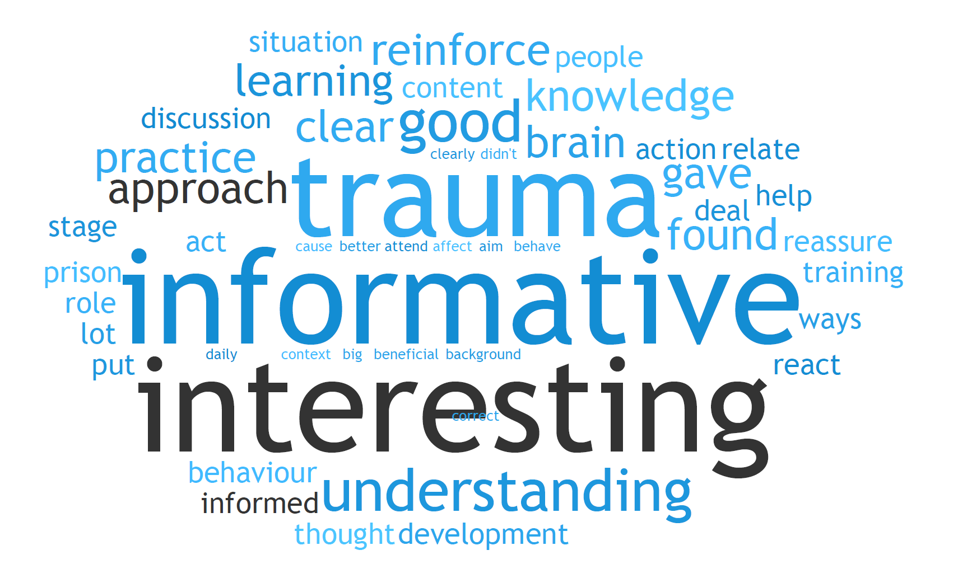

The reason I found the training useful/interesting
Response theme | Number
Practical tools to use in practice | 17
Learning a new approach | 12
Learning about reasons behind behaviours or actions | 12
Interesting and informative content | 11
Reinforce existing practice | 8
Clearer insights into trauma | 6
Instructors with lived experience, well run and presented | 6
Insights into brain development | 4
Inclusive, understandable content | 3
Relevance to practice | 2
Insight into language used | 2
Interactive format | 2

Please identify elements of the training that worked well and/or that could be improved – Word cloud
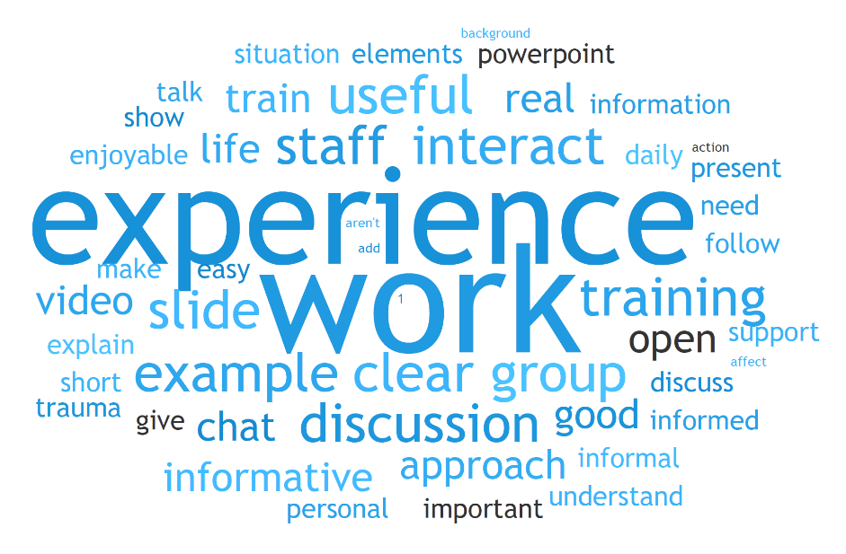

Response theme | Number
Presenter features (with operational experience, well organized, inclusive) | 17
Interactive nature that includes discussions and chatting about real experiences | 15
Providing interesting insights for practice | 7
In-depth explanations that were easy to understand | 4
Powerpoints were interesting and well crafted | 3
Use of real experiences in examples | 2
Videos / language examples | 2

How will your practice change as a result of anything you learned today? – Word cloud
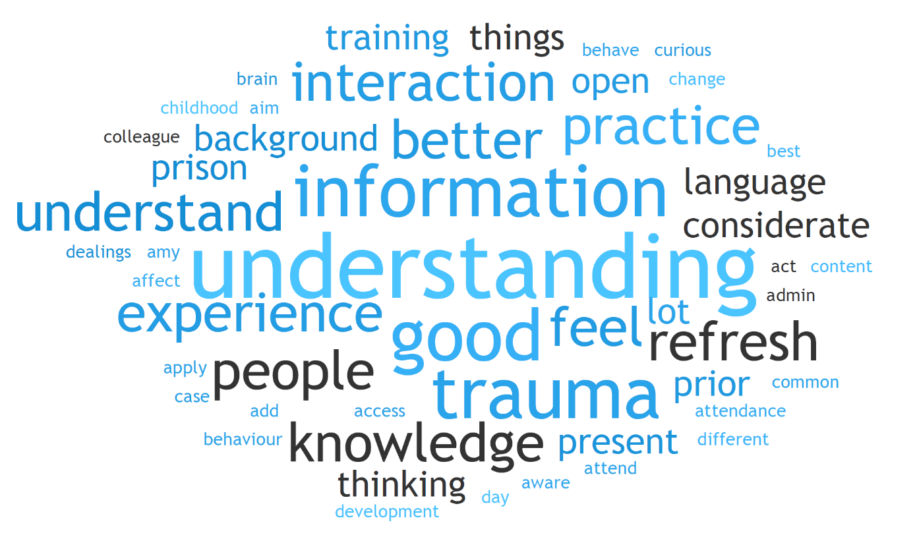

Response theme | Number
Be more open minded / considerate / understanding | 11
Continue / build on existing practice | 7
Use insight into trauma | 5
As more questions | 4
Use different language / terminology | 4
Be more supportive of colleagues | 1
Utilise new skills and tools | 1

References
1. Stensrud, R.H., D.D. Gilbride, and R.M. Bruinekool, The childhood to prison pipeline: Early childhood trauma as reported by a prison population. Rehabilitation Counseling Bulletin, 2019. 62(4): p. 195-208.
2. Levenson, J.S. and G.M. Willis, Implementing trauma-informed care in correctional treatment and supervision. Journal of Aggression, Maltreatment & Trauma, 2019. 28(4): p. 481-501.
3. Stewart, H., et al., Lancashire Violence Reduction Network: Trauma-Informed programmes. Lancaster University Applied Research Collaboration ARC BITE, 2022.
4. Mind UK, What is trauma? Available at https://www.mind.org.uk/information-support/types-of-mental-health-problems/trauma/about-trauma/ [Accessed 20/06/2024], 2024.
5. Mental Health Foundation, Trauma informed practice: Our policy perspective. Available at: https://www.mentalhealth.org.uk/explore-mental-health/a-z-topics/trauma [Accessed 20/06/2024], 2024.
6. Auty, K.M., et al., What is trauma-informed practice? Towards operationalisation of the concept in two prisons for women. Criminology & Criminal Justice, 2023. 23(5): p. 716-738.
7. Covington, S.S., A woman's journey home: Challenges for female offenders. 2002: US Department of Health and Human Services.
8. Vaswani, N. and S. Paul, ‘It's Knowing the Right Things to Say and Do’: Challenges and Opportunities for Trauma‐informed Practice in the Prison Context. The Howard Journal of Crime and Justice, 2019. 58(4): p. 513-534.
9. Substance Abuse and Mental Health Services Administration, SAMHSA’s concept of trauma and guidance for a trauma-informed approach. 2014.
10. Miller, N.A. and L.M. Najavits, Creating trauma-informed correctional care: A balance of goals and environment. European journal of psychotraumatology, 2012. 3(1): p. 17246.
11. Petrillo, M., ‘We've all got a big story’: Experiences of a Trauma‐Informed Intervention in Prison. The Howard Journal of Crime and Justice, 2021. 60(2): p. 232-250.
12. Wilson, H., et al., Understanding the potential of trauma-informed training in Violence Reduction Units. London: The EIF Foundation, 2022.
13. Goldthorpe, J., et al., Lancashire Violence Reduction Network Trauma Informed Programmes Evaluation Report 2021/22 Equitable approaches to Place-based Health and Care theme, NIHR Applied Research Collaboration North West Coast, Lancaster University 2022.

